References

1. **Journals**

Alawad, A.,Aljoufie, M., Tiwari, A., & Daghestani L. (2015). Beyond Geographical and Cultural Barriers: The Concept of a Virtual Gallery for Arts, Design & Architecture Schools in Saudi Arabia. Retrieved from Scientific Research: <https://www.scirp.org/html/1-1250089_61105.htm>

Chen, T. L., Lai, W. C., & Yu, T. K. (2021, January 11). Participating in Online Museum Communities: An Empirical Study of Taiwan’s Undergraduate Students. Frontiers in Psychology, *Volume*11, https//10.3389/fpsyg.2020.565075, ISSN=1664-1078, Retrieved May 11, 2022, from https://www.frontiersin.org/articles/10.3389/fpsyg.2020.565075/full

Chong, C., & Smith, D. (2017). Interactive Learning Units on museum websites. Journal of Museum Education, 42(2), 169–178. https://doi.org/10.1080/10598650.2017.1301626

Li J., Nie J-W, Ye J. (2022) Evaluation of virtual tour in an online museum: Exhibition of Architecture of the Forbidden City: <https://journals.plos.org/plosone/article?id=10.1371/journal.pone.0261607#sec005>

Lin, M., Chen, H., & Liu, K. (2017). A Study of the Effects of Digital Learning on Learning Motivation and Learning Outcome. *Eurasia journal of mathematics, science and technology education, 13*, 3553-3564.

Madriaga, J. G., Virto, N. R., & Blaso, F. (2017, August). *The influence of museums’ websites on users’ intentions*. Retrieved from ResearchGate:https://www.researchgate.net/publication/318701715\_The\_influence\_of\_museums'\_websites\_on\_users'\_intentions

Kabassi, K. (2017). Evaluating websites of museums: State of the art. Journal of Cultural Heritage, Volume 24 - Pages 184-196.

Lopatovska, Irene. (2015). Museum website features, aesthetics, and visitors’ impressions: a case study of four museums. Museum Management and Curatorship. 30. 191-207. 10.1080/09647775.2015.1042511.

Schweibenz, Werner. (2019). The virtual museum: an overview of its origins, concepts, and terminology. 4.

Tambahani, G., Wenas, M., & Somya, R. (2016). Perancangan Online Virtual Gallery Dengan Memanfaatkan Teknologi HTML5. AITI, 13(1), 15-30. Retrieved from <https://ejournal.uksw.edu/aiti/article/view/1260>

Walsh, D., Hall, M. H., Clough, P., & Foster, J. (2020). Characterizing online museum users: a study of the National Museums. International Journal on Digital Libraries, 21:75–87.

Z. Liu, M. Wang, S. Qi and C. Yang (2019), Study on the Anti-Theft Technology of Museum Cultural Relics Based on Internet of Things: <https://ieeexplore.ieee.org/document/8788595>

1. **Electronic References**

Albadawi, Bushra Izzat (2021) “The Virtual Museum VM as a Tool for Learning Science in Informal Environment”: <https://dspace.alquds.edu/items/67d230e5-8864-4e74-b8a7-e157c33b1f24/full>

Aldrich, E., Bessette, K., Mueller, P., & Prakash, M. (2016). Evaluating Digital Learning Resources for International Students at the British Museum (Doctoral dissertation, WORCESTER POLYTECHNIC INSTITUTE).

Allen, L. B., & Crawley, K. J. (2013, November 25). *Challenging Beliefs, Practices, and Content: How Museum Educators Change*. Retrieved from Wiley Online Library:https://onlinelibrary.wiley.com/doi/10.1002/sce.21093

Anggai, S., Blekanov, I. S., & Sergeev, L. S. (2015). "Design Muntoi web-based framework and search engine analytics for thematic virtual museums,". 2015 4th International Conference on Interactive Digital Media (ICIDM), pp. 1-5, doi: 10.1109/IDM.2015.7516334.

Balanchine, S. (2018, September 29). *Museum Marketing Challenges and Solutions in Digital Transformation Era*. Retrieved from Cetrix:https://www.cetrixcloudservices.com/blog/museum-marketing-challenges-and-solutions-in-digital-transformation-era

Billock, J. (2020, September 16). *How Will Covid-19 Change the Way Museums Are Built?* Retrieved from Smithsonian:https://www.smithsonianmag.com/travel/how-will-covid-19-change-way-future-museums-are-built-180975022/

Butler, J. (2017, August 31). *Five takeaways on how museums are adapting to digital age demands*. Retrieved from Knight Foundation:<https://knightfoundation.org/articles/five-takeways-on-how-museums-are-adapting-to-digital-age-demands/>

Charr, M. (2020). *What makes a good museum website?* Retrieved from Museum Next:https://www.museumnext.com/article/what-makes-a-good-museum-website/

Chen, T. L., Lai, W. C., & Yu, T. K. (2021, January 11). Participating in Online Museum Communities: An Empirical Study of Taiwan’s Undergraduate Students. Frontiers in Psychology, Volume11, https//10.3389/fpsyg.2020.565075, ISSN=1664-1078, Retrieved May 11, 2022, from https://www.frontiersin.org/articles/10.3389/fpsyg.2020.565075/full

Cristóbal, E. F., Ramón, J. C., Daries, N., & Serra, A. C. (2021, August 20). Museums in the Digital Age: An Analysis of Online Communication and the Use of E-Commerce. Retrieved from Digital Library: <https://dl.acm.org/doi/abs/10.1145/3464977>

Fernandez, S. L., Crespo, N. T., & Fernández, R. H. (2022, January). Driving traffic to the museum: The role of the digital communication tools. *Volume*174, https://doi.org/10.1016/j.techfore.2021.121273. Retrieved from Science Direct: https://www.sciencedirect.com/science/article/abs/pii/S0040162521007071#!

Komarova, M. (2015). INTERACTIVE TECHNOLOGIES ON ART MUSEUM WEBSITES. Manhattan, Kansas, Moscow. <https://krex.k-state.edu/dspace/bitstream/handle/2097/18947/%20MariaKomarova2015.pdf?sequence=1>

Laura A. Maye, Dominique Bouchard, Gabriela Avram, and Luigina Ciolfi. 2017. r In Proceedings of the 2017 Conference on Designing Interactive Systems (DIS '17). Association for Computing Machinery, New York, NY, USA, 221–232. <https://doi.org/10.1145/3064663.3064753>

[Raimo, N.](https://www.emerald.com/insight/search?q=Nicola%20Raimo), [De Turi, I.](https://www.emerald.com/insight/search?q=Ivano%20De%20Turi), [Ricciardelli, A.](https://www.emerald.com/insight/search?q=Alessandra%20Ricciardelli" \t "_blank) and [Vitolla, F.](https://www.emerald.com/insight/search?q=Filippo%20Vitolla" \t "_blank) (2021), "Digitalization in the cultural industry: evidence from Italian museums", [International Journal of Entrepreneurial Behavior & Research](https://www.emerald.com/insight/publication/issn/1355-2554), Vol. ahead-of-print No. ahead-of-print. <https://doi.org/10.1108/IJEBR-01-2021-0082>

C. Di Stefano and F. Battisti, "Caravaggio in Rome: A qoe-based proposal for a virtual gallery," *2017 3DTV Conference: The True Vision - Capture, Transmission and Display of 3D Video (3DTV-CON)*, 2017, pp. 1-4, doi: 10.1109/3DTV.2017.8280423.

*History of Flight Booking: CRSs, GDS Distribution, Travel Agencies, and Online Reservations*. (2019, April 12). Retrieved from altexsoft: https://www.altexsoft.com/blog/travel/history-of-flight-booking-crss-gds-distribution-travel-agencies-and-online-reservations/

Ruiz, O. O. (2020, June 2). *The 10 “must-have” features of an online booking system*. Retrievedfrombookingkit:https://bookingkit.com/blog/10-must-features-online-booking-system/

Steeves, K. (2020, October 1). *What Exactly Is an Online Booking System?* Retrieved fromcheckfront:https://www.checkfront.com/blog/what-is-an-online-booking-system#:~:text=An%20online%20booking%20system%20is,operation%2C%20all%20in%20one%20place.

*THE HISTORY OF BOOKING SYSTEMS* (2021, September 15).. Retrieved from scandinaviantraveler:https://scandinaviantraveler.com/en/aviation/the-history-of-booking-systems

Appendices

Appendix A

Relevant Source Code

CLIENT SIDE - homepage.php

<!DOCTYPE html>

<html>

<meta name="viewport" content="with=device-width, initial-scale=1.0">

<head>

<title>Homepage - VirtualShrine</title>

<link rel="stylesheet" href="assets/css/homepage.css">

<link rel="preconnect" href="https://fonts.googleapis.com">

<link rel="icon" type="image/png" href="assets/img/crs-logo.png">

<link rel="preconnect" href="https://fonts.gstatic.com" crossorigin>

<link rel="stylesheet" href="https://cdnjs.cloudflare.com/ajax/libs/font-awesome/6.2.0/css/all.min.css">

<link rel="stylesheet" href="https://stackpath.bootstrapcdn.com/font-awesome/4.7.0/css/font-awesome.css">

<script src="https://cdnjs.cloudflare.com/ajax/libs/jquery/3.6.1/jquery.min.js" charset="utf-8"></script>

<link href="https://fonts.googleapis.com/css2?family=Poppins:wght@100;200;300;400;600;700&display=swap" rel="stylesheet">

</head>

<body>

<!-- push -->

<section class="header">

<nav>

<a href="homepage.php"><image class="logo" src="assets/img/crs-logo-white.png" alt="Casa Real Shrine logo"></image></a>

<div class="nav-links" id="mySidebar">

<i class="fa fa-times" onclick="closeNav()"></i>

<ul>

<li class="menu-item"><a href="homepage.php">HOME</a></li>

<li class="menu-item">

<a href="#">VISIT <i class="fas fa-angle-down"></i></a>

<ul class="sub-menu">

<li class="sub-item"><a href="plan\_visit.php">Plan Your Visit</a></li>

<li class="sub-item"><a href="consent-form.php">Book a Visit</a></li>

<li class="sub-item"><a href="audio-guide.php">Audio Guide</a></li>

<li class="sub-item"><a href="exhibits.php">Exhibits</a></li>

</ul>

</li>

<li class="menu-item">

<a href="#">EXPLORE<i class="fas fa-angle-down"></i></a>

<ul class="sub-menu">

<li class="sub-item"><a href="gallery.php">Collections</a></li>

<li class="sub-item"><a href="virtual-tour.php">Virtual Tour</a></li>

</ul>

</li>

<li class="menu-item"><a href="blog.php">BLOG</a></li>

<li class="menu-item"><a href="about-crs.php">ABOUT</a></li>

</ul>

</div>

<div id="main"></div>

<i class="fa fa-bars" onclick="openNav()"></i>

</div>

</nav>

<!-- [END] NAVIGATION -->

<!-- [START] HEADER -->

<div class="text-box">

<h1>WELCOME TO THE VIRTUALSHRINE</h1>

<p>Free Entry - Operation time : 8:00AM - 4:00PM</p>

<a class="book-btn" href="consent-form.php">Book a Visit Now</a>

</div>

<!-- [END] OF HEADER -->

</section>

<!-- [START] STARTING PAGE -->

<section class="content-split">

<h1>ABOUT CASA REAL SHRINE</h1>

<div class="content-wrap">

<div class="content-split-side rich-text">

<div class="carousel">

<div class="carousel-inner">

<div class="carousel-item">

<img src="Images/about/history-of-casa-real-shrine.jpg" alt="">

</div>

<div class="carousel-item">

<img src="Images/about/women-of-malolos.jpg" alt="">

</div>

<div class="carousel-item">

<img src="Images/about/crs-printing-press.jpg" alt="">

</div>

<div class="carousel-item">

<img src="Images/about/thumb2.jpg" alt="">

</div>

</div>

<div class="carousel-controls">

<span class="prev"></span>

<span class="next"></span>

</div>

<div class="carousel-indicators"></div>

</div>

</div>

<div class="content-split-main rich-text">

<p class="about-desc">Located at Paseo del Congreso, Plaza Rizal Malolos Bulacan, Casa Real Shrine served as the

National Museum and the National Printing Press during the First Philippine Republic. It

is a government museum consisting of relics from the First Philippine Republic.

Memorabilia's of Gen. Emilio Aguinaldo are also found here. First class families of Malolos,

their furnitures, old books, stamps, paper money and coin are also displayed in the Shrine.</p>

<p class="about-desc-2">Casa Real is also one of Malolos oldest structure. The building contains

exhibits, printing press of the Malolos Republic and a display of the 21 Women of Malolos

memorabilia. Also presented here are the photographs of the 100 Filipino women. Each of them has

distinct characteristics in their fields.</p>

<a href="about-crs.php"><button class="button-31" role="button">Learn More</button></a>

</div>

</div>

</section>

<!-- [END] STARTING PAGE -->

<!-- [START] HOMEPAGE CONTENTS -->

<section class="home-content">

<h1>Explore Our Galleries</h1>

<p>Tour the 5 galleries of Casa Real Shrine</p>

<div class="row">

<a href="GalleryInfo.php">

<div class="gallery-col">

<img src="Images/homepage-gallery/ginhawa.jpg" alt="kaginhawaan">

<div class="layer">

<h3>KAGINHAWAAN</h3>

</div>

</div>

</a>

<a href="GalleryInfo.php">

<div class="gallery-col">

<img src="Images/homepage-gallery/paniil.jpg" alt="kaginhawaan">

<div class="layer">

<h3>PANINIIL</h3>

</div>

</div>

</a>

<a href="GalleryInfo.php">

<div class="gallery-col">

<img src="Images/homepage-gallery/bago-puri.jpg" alt="kaginhawaan">

<div class="layer">

<h3>PAGBABAGONG-PURI</h3>

</div>

</div>

</a>

<a href="GalleryInfo.php">

<div class="gallery-col">

<img src="Images/homepage-gallery/buo.jpg" alt="kaginhawaan">

<div class="layer">

<h3>PAGBUBUO NG BAYAN</h3>

</div>

</div>

</a>

</div>

</section>

<!-- [END] OF HOMEPAGE CONTENTS -->

<!-- [START] VIRTUALSHRINE NEXT TO YOU -->

<section class="vs-features">

<h1>VIRTUALSHRINE NEXT TO YOU</h1>

<p>Explore our virtual tours and experience the Casa Real wherever you are</p>

<div class="row">

<div class="features-col">

<a href="audio-guide.php">

<div id="container">

<img id="image" src="Images/homepage-features/image1.jpg" alt="">

</div>

</a>

<div class="card-title">

<h3>Audio Guide</h3>

<p>Explore Casa Real with an Audio Guide</p>

</div>

</div>

<div class="features-col">

<a href="virtual-tour.php">

<div id="container">

<img id="image" src="Images/homepage-features/image2.JPG" alt="">

</div>

</a>

<div class="card-title">

<h3>Virtual 360</h3>

<p>Check out the virtual 360 tour of the Casa Real Shrine</p>

</div>

</div>

<div class="features-col">

<a href="gallery.php">

<div id="container">

<img id="image" src="Images/homepage-features/image3.jpg" alt="">

</div>

</a>

<div class="card-title">

<h3>Collections</h3>

<p>Learn the political history of the Phillipines by visiting the collections of Casa Real Shrine</p>

</div>

</div></div>

</div>

</section>

<!-- [END] OF VIRTUALSHRINE NEXT TO YOU-->

<!-- [START] FOOTER -->

<section id="footer">

<div class="title-text">

<!-- <h1>Visit Casa Real Today</h1> -->

</div>

<div class="footer-row">

<div class="footer-left">

<div>

<h1>Opening Hours</h1>

<p><i class="fa fa-clock-o"></i> Tuesday to Sunday - 8:00 AM to 4:00 PM</p>

</div>

<br>

<div>

<h1>Contact Us</h1>

<p><i class="fa fa-map-marker"></i> Paseo Del Congreso, Liang, City of Malolos, Bulacan</p>

<p><i class="fa fa-paper-plane"></i> mpph@nhcp.gov.ph</p>

<p><i class="fa fa-phone"></i> (044) 931-2508</p>

</div>

</div>

<div class="footer-right">

<div>

<h1>Quicklinks</h1>

<div class="quicklinks">

<span style="margin-right:50px;"><a href="homepage.php">Homepage</a></span><a href="crs-about.php">About Us</a><br>

<span style="margin-right:30px;"><a href="plan\_visit.php">Plan Your Visit</a></span><a href="consent-form.php">Book a Visit</a><br>

<span style="margin-right:70px;"><a href="audio-guide.php">Audio Guide</a></span><a href="exhibits.php">Exhibit</a><br>

<span style="margin-right:30px;"><a href="gallery.php">Collection</a></span><a href="virtual-tour.php">Virtual Tour</a><br>

<span><a href="">About</a></span>

</div>

</div>

</div>

</div>

<div class="social-links">

<img src="Images/Logo.png" class="footer-img">

<a href="https://www.facebook.com/CasaRealMalolos"><i class="fa fa-facebook"></i></a>

<a href="https://www.instagram.com/nhcpofficial/"><i class="fa fa-instagram"></i></a>

<a href="https://twitter.com/NHCPOfficial"><i class="fa fa-twitter"></i></a>

<a href="https://www.youtube.com/@NHCPOfficial"><i class="fa fa-youtube-play"></i></a>

<p>2022 <i class="fa-regular fa-copyright"></i> VirtualShrine</p>

</div>

</section>

<!-- [END] FOOTER -->

<!-- JAVASCRIPT FOR TOGGLE MENU -->

<script>

/\* Set the width of the sidebar to 250px and the left margin of the page content to 250px \*/

function openNav() {

document.getElementById("mySidebar").style.width = "250px";

}

/\* Set the width of the sidebar to 0 and the left margin of the page content to 0 \*/

function closeNav() {

document.getElementById("mySidebar").style.width = "0";

}

</script>

<script src="assets/js/swiper-script.js"></script>

</body>

</html>

ADMIN SIDE – login.php

<?php

session\_start();

?>

<html>

<head>

<title>Login - VirtualShrine</title>

<meta name="MobileOptimized" content="width">

<meta name="HandheldFriendly" content="true">

<meta name="viewport" content="width=device-width, minimum-scale=1.0, maximum-scale=1.0, user-scalable=no">

<link rel="icon" type="image/png" href="image/VirtualShrineLogo.png">

<link rel="stylesheet" href="assets/css/login-style.css">

<link rel="stylesheet" href="https://cdnjs.cloudflare.com/ajax/libs/font-awesome/6.2.0/css/all.min.css">

<script src="https://cdnjs.cloudflare.com/ajax/libs/jquery/3.6.1/jquery.min.js" charset="utf-8"></script>

</head>

<div class="py5">

<div class="container">

<div class="row justify-content-center">

<div class="col-md-5">

<div class="card">

<div class="card-header">

<img src="image/VirtualShrineLogo.png">

<div class="center">

<div class="center-header">

<h1>Login</h1>

</div>

<hr>

<div class="center-body">

<?php include('message.php')?>

<form action="logincode.php" method="post">

<div class="txt\_field">

<input type="username" required name="username">

<label>Username</label>

</div>

<div class="txt\_field">

<input type="password" required name="password">

<span></span>

<label>Password</label>

</div>

<input type="submit" name="login\_btn" class="btn btn-primary" value="Login"></input>

<div class="MainAdmin\_link"></div>

</form>

</div>

</div>

</div>

</div>

</div>

</div>

</div>

</div>

<!-- Modal

<div class="modal fade" id="no-slot" tabindex="-1" role="dialog" aria-labelledby="exampleModalLabel" aria-hidden="true">

<div class="modal-dialog" role="document">

<div class="modal-content">

<div class="modal-body" id="loading-msg">

</div>

<div class="modal-footer">

<button type="button" class="btn btn-secondary" data-dismiss="modal">Ok</button>

</div>

</div>

</div>

</div>

<script src="assets/js/main.js?v1"></script>

<script src="assets/js/parsely.min.js"></script>

<script src="assets/js/popper.min.js"></script>

<script src="assets/js/bootstrap.min.js"></script> -->

<script src="https://cdn.jsdelivr.net/npm/bootstrap@5.1.3/dist/js/bootstrap.bundle.min.js"></script>

</body>

</html>

Virtual Tours – index.html

<!DOCTYPE html>

<html>

<head>

<meta http-equiv="Content-Type" content="text/html;charset=UTF-8" />

<meta http-equiv="X-UA-Compatible" content="IE=edge" />

<title>Virtual Tour - VirtualShrine</title>

<link rel="icon" type="image/png" href="img/crs-logo.png">

<meta name="viewport" content="width=device-width, initial-scale=1.0, minimum-scale=1.0, maximum-scale=1.0" />

<meta name="apple-mobile-web-app-capable" content="yes" />

<meta name="apple-mobile-web-app-status-bar-style" content="black" />

<meta name="mobile-web-app-capable" content="yes" />

<style type="text/css" title="Default">

/\* fullscreen \*/

html {

height:100%;

}

body {

height:100%;

margin: 0px;

overflow:hidden; /\* disable scrollbars \*/

-webkit-tap-highlight-color: rgba(0, 0, 0, 0); /\* remove highlight on tab for iOS/Android \*/

}

/\* fix for scroll bars on webkit & >=Mac OS X Lion \*/

::-webkit-scrollbar {

background-color: rgba(0,0,0,0.5);

width: 0.75em;

}

::-webkit-scrollbar-thumb {

background-color: rgba(255,255,255,0.5);

}

</style>

</head>

<body>

<!-- - - - - - - 8<- - - - - - cut here - - - - - 8<- - - - - - - -->

<script type="text/javascript" src="pano2vr\_player.js">

</script>

<script type="text/javascript" src="skin.js">

</script>

<div id="container" style="width:100%;height:100%;overflow:hidden;">

<br>Loading...<br><br>

</div>

<script type="text/javascript">

// create the panorama player with the container

pano=new pano2vrPlayer("container");

// add the skin object

skin=new pano2vrSkin(pano);

// load the configuration

window.addEventListener("load", function() {

pano.readConfigUrlAsync("pano.xml");

});

if (window.navigator.userAgent.match(/Safari/i)) {

// fix for white borders, rotation on iPhone

function iosHfix(e) {

window.scrollTo(0, 1);

var container=document.getElementById("container");

var oh=container.offsetHeight;

document.documentElement.style.setProperty('height', '100vh');

if (oh!=container.offsetHeight) {

container.style.setProperty('height',"100%");

} else {

container.style.setProperty('height',window.innerHeight+"px");

}

window.scrollTo(0, 0);

pano.setViewerSize(container.offsetWidth, container.offsetHeight);

};

setTimeout(iosHfix,0);

setTimeout(iosHfix,100);

window.addEventListener("resize", function() {

setTimeout(iosHfix,0);

// hide toolbar on iPad happens with a delay

setTimeout(iosHfix,500);

setTimeout(iosHfix,1000);

setTimeout(iosHfix,2000);

});

}

</script>

<noscript>

<p><b>Please enable Javascript!</b></p>

</noscript>

<!-- - - - - - - 8<- - - - - - cut here - - - - - 8<- - - - - - - -->

</body>

</html>

Appendix B

Evaluation Tool

|  |  |  |
| --- | --- | --- |
| **Scale** | **Range** | **Descriptive Interpretation** |
| 5 | 4.60 - 5.00 | Strongly Agree |
| 4 | 3.60 – 4.59 | Agree |
| 3 | 2.69 – 3.59 | Moderately Agree |
| 2 | 1.60 – 2.59 | Disagree |
| 1 | 0 – 1.59 | Strongly Disagree |

**Name: \_\_\_\_\_\_\_\_\_\_\_\_\_\_\_\_\_\_\_\_\_\_\_\_\_\_\_ Date: \_\_\_\_\_\_\_\_\_\_\_\_\_\_\_  
Type of Respondent: \_\_\_\_\_\_\_\_\_\_\_\_\_\_\_**

|  |  |  |  |  |  |
| --- | --- | --- | --- | --- | --- |
| **Indicator** | **5** | **4** | **3** | **2** | **1** |
| 1. **Function and Stability** |  |  |  |  |  |
| 1. The system functions according to its intended purpose. |  |  |  |  |  |
| 1. The system gives the exact output on each input per module. |  |  |  |  |  |
| 1. The system functions like any standard system entirely |  |  |  |  |  |
| 1. The system functions to different user with different restrict ions. |  |  |  |  |  |
| 1. The system interacts to different inputs and features entirely. |  |  |  |  |  |
| 1. **Performance and Efficiency** |  |  |  |  |  |
| 1. The system meets the user’s expectation and objectives. |  |  |  |  |  |
| 1. The system can be used to its maximum limit from the design capacity. |  |  |  |  |  |
| 1. The system can respond to multiple interaction from the user. |  |  |  |  |  |
| 1. The system manages time efficiently and effectively. |  |  |  |  |  |
| 1. The system accurately presents the output at the maximum level. |  |  |  |  |  |
| 1. **Compatibility** |  |  |  |  |  |
| 1. Co-Existence. The system can efficiently perform its required functions while sharing a familiar environment and resources with other systems, with no negative influence on any other method. |  |  |  |  |  |
| 1. Interoperability. The system can exchange information and utilize data that has been exchanged between two or more platforms. |  |  |  |  |  |
| 1. The system can be accessed on both phone and computer browsers. |  |  |  |  |  |
| 1. **Usability** |  |  |  |  |  |
| 1. User friendly. The design of the system is easy to understand and use. |  |  |  |  |  |
| 1. Acceptability Recognizability. Users are able to determine whether the system is suitable for their requirements. |  |  |  |  |  |
| 1. System Utility. The system can generate reports that can be viewed online (and can be download). |  |  |  |  |  |
| 1. Operability. The system is simple to use, navigate. |  |  |  |  |  |
| 1. **Reliability** |  |  |  |  |  |
| 1. Maturity. Under normal conditions, the system meets the requirements for reliability. |  |  |  |  |  |
| 1. Availability. The system is operational and accessible when required for use. |  |  |  |  |  |
| 1. Fault Tolerance. Despite the presence of hardware or software faults, the system or its components function as planned. |  |  |  |  |  |
| 1. Recoverability. In an interruption or failure, the system can immediately recover the affected data and restore the system to its desired state. |  |  |  |  |  |
| 1. **Security** |  |  |  |  |  |
| 1. Confidentiality. The system guarantees that the data is only available to those granted access. |  |  |  |  |  |
| 1. Confidentiality. The system guarantees that the data is only available to those granted access. |  |  |  |  |  |
| 1. Accountability. The actions of an entity can be traced uniquely by the system to the entity. |  |  |  |  |  |
| 1. **Maintainability** |  |  |  |  |  |
| 1. The system’s information and interfaces can be updated through administrator account. |  |  |  |  |  |
| 1. The system allows updating different user records through level of security. |  |  |  |  |  |
| 1. The system username and password can be modified online. |  |  |  |  |  |
| 1. The system’s hierarchy of authority especially administrator and super administrator can monitor different user’s account online. |  |  |  |  |  |
| 1. **Portability** |  |  |  |  |  |
| 1. Adaptability. The system can effectively and efficiently be adapted for different evolving hardware, software, or other operational or usage environments. |  |  |  |  |  |

Appendix C

Letter to the Casa Real Shrine Curator



Republic of the Philippines

Bulacan State University

##### City of Malolos, Bulacan

##### Tel (044) 919 7800 local 1101/1102

##### 

**COLLEGE OF INFORMATION AND COMMUNICATIONS TECHNOLOGY**

May 16, 2022

**MRS. MA. ANTONIA T. JIMENEZ**

Museum Curator

Casa Real Shrine

Dear Mrs. Jimenez:

Greetings!

We are 3rd-year college students from Bulacan State University taking up the course of Bachelor of Science in Information Technology. We've decided to design a website for our capstone project a VirtualShrine: An Interactive Museum website for Casa Real Shrine that will be utilized to virtualize Casa Real Shrine. As for that, we are asking for your permission to be our client on this project.

           The concept of our proposed system is to deliver more knowledge to the online museum user by improving users’ experience, interactivity, and comprehensive knowledge. This proposed project website could also serve as promotion for the Casa Real Shrine of Malolos to a vast audience online.

This system can help you on:

* Promote the Casa Real Shrine on a wider audience online.
* Online Booking Admission
* User Assisting features
* Virtual Museum tours

Students will use the information provided above for educational purposes only. We are hoping for your kind consideration and favorable response. Thank you, and God bless!

**Respectfully yours,**

**The Researchers**

**Claro, Sharvien Paul M.**

**Gabutina, Carlo Elijah R.**

**Mauricio, Angelo D.**

**Navarro, Rovi Keith Y.**

**Tapang, Jhel Ansel D.**

**Nacional, Kristine Joy S.**

Project Leader

BSIT 3M – Group 2

**Noted by:**

**Dr. Mayleen Dorcas Castro**

Capstone Coordinator

**Conforme:**

**Mrs. Ma. Antonia T. Jimenez**

Museum Curator

**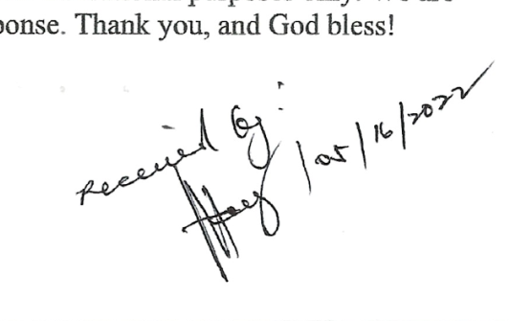**

Bulacan State University

**COLLEGE OF INFORMATION & COMMUNICATIONS**

**TECHNOLOGY**

City of Malolos 3000, Bulacan

Tel. No. (044) 796-0147/(044)791-7386

<http://www.bulsu.edu.ph/>

July 7, 2022

**MRS. MA. ANTONIA T. JIMENEZ**

Museum Curator

Casa Real Shrine

Dear Mrs. Jimenez:

Greetings!

This letter is in regard to requesting for Data collection such as images, description, and 360-degree view of the artifacts displayed in your museum. We are 3rd-year college students from Bulacan State University taking up the course of Bachelor of Science in Information Technology conducting a study entitled “VirtualShrine: an interactive website for Casa Real Shrine”.

As part of the study's development, we will photograph the artifacts on display at the museum and capture a 360-degree view of each gallery. We would also want to request a description of the artifacts that are on display.

The intention of our work is to use those data as contents for the interactive museum website for Casa Real Shrine and be able to share the collected data to the museum website visitors.

We will be very grateful to you for your help. We can assure you that your privacy will not be affected.

If you have any further queries, you can reach us at virtualshrine.developers@gmail.com

**Respectfully yours,**

**The Researchers**

**Claro, Sharvien Paul M.**

**Gabutina, Carlo Elijah R.**

**Mauricio, Angelo D.**

**Navarro, Rovi Keith Y.**

**Tapang, Jhel Ansel D.**

**Nacional, Kristine Joy S.**

Project Leader

BSIT 3M – Group 2

**Noted by:**

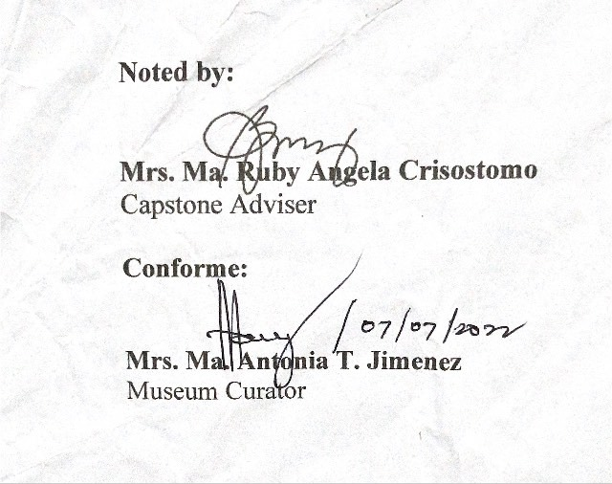

**Mrs. Ma. Ruby Angela Crisostomo**

Capstone Adviser

**Conforme:**

**Mrs. Ma. Antonia T. Jimenez**

Museum Curator

Appendix D

Request Letter for Capstone Adviser



Bulacan State University

**COLLEGE OF INFORMATION & COMMUNICATIONS**

**TECHNOLOGY**

City of Malolos 3000, Bulacan

Tel. No. (044) 796-0147/(044)791-7386

<http://www.bulsu.edu.ph/>

**MRS. MA. RUBY ANGELA CRISOSTOMO** March 31, 2022

CICT Faculty Member

Bulacan State University

Dear Mrs. Crisostomo:

Greetings!

We, the undersigned, are third year students of Bulacan State University pursuing a degree, Bachelor of Science in Information Technology and currently taking Capstone I subject.

We are writing to humbly request your service and expertise to serve as an adviser for our Capstone project. We believe that your knowledge and insights will be valuable and will greatly enrich our work.

Hoping & praying that you will consider our request. Thank you very much & God bless!

**Respectfully yours,**

The Researchers

**Claro, Sharvien Paul M.**

**Gabutina, Carlo Elijah R.**

**Mauricio, Angelo D.**

**Nacional, Kristine Joy S.**

**Navarro, Rovi Keith Y.**

**Tapang, Jhel Ansel D.**

**Noted by:**



**Dr. Mayleen Dorcas B. Castro**

Capstone Coordinator

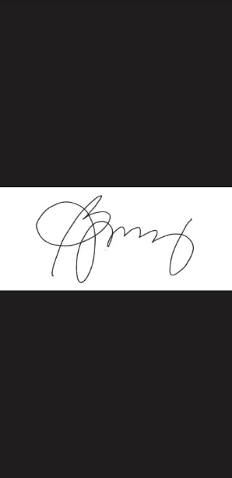**Conforme:**

**Mrs. Ma. Ruby Angela Crisostomo**

CICT, Faculty

Appendix E

Request Letter for Capstone Panels

Bulacan State University

**COLLEGE OF INFORMATION & COMMUNICATIONS**

**TECHNOLOGY**

City of Malolos 3000, Bulacan

Tel. No. (044) 796-0147/(044)791-7386

<http://www.bulsu.edu.ph/>



**MS. LILIBETH ANTONIO**  April 4, 2022

CICT Faculty Member

Bulacan State University

Dear Ms. Antonio:

Greetings!

We, the undersigned, are third year students of Bulacan State University pursuing a degree, Bachelor of Science in Information Technology and currently taking Capstone I subject.

We are writing to humbly request your service and expertise to serve as one of our panel members for our Capstone project Title Oral Presentation. We believe that your knowledge and insights will be valuable and will greatly enrich our work.

Hoping & praying that you will consider our request. Thank you very much & God bless!

**Respectfully yours,**

The Researchers

**Claro, Sharvien Paul**

**Gabutina, Carlo Elijah**

**Mauricio, Angelo**

**Nacional, Kristine Joy**

**Navarro, Rovi Keith**

**Tapang, Jhel Ansel**

**Noted by:**



**Dr. Mayleen Dorcas B. Castro**

Capstone Coordinator

**Conforme:**

**Ms. Lilibeth Antonio**

CICT, Faculty

Bulacan State University

**COLLEGE OF INFORMATION & COMMUNICATIONS**

**TECHNOLOGY**

City of Malolos 3000, Bulacan

Tel. No. (044) 796-0147/(044)791-7386

<http://www.bulsu.edu.ph/>



**ENGR. TERESITA MANGAHAS**  April 4, 2022

CICT Faculty Member

Bulacan State University

Dear Engr. Mangahas:

Greetings!

We, the undersigned, are third year students of Bulacan State University pursuing a degree, Bachelor of Science in Information Technology and currently taking Capstone I subject.

We are writing to humbly request your service and expertise to serve as one of our panel members for our Capstone project Title Oral Presentation. We believe that your knowledge and insights will be valuable and will greatly enrich our work.

Hoping & praying that you will consider our request. Thank you very much & God bless!

**Respectfully yours,**

The Researchers

**Claro, Sharvien Paul**

**Gabutina, Carlo Elijah**

**Mauricio, Angelo**

**Nacional, Kristine Joy**

**Navarro, Rovi Keith**

**Tapang, Jhel Ansel**

**Noted by:**



**Dr. Mayleen Dorcas B. Castro**

Capstone Coordinator

****

**Conforme:**

**Engr. Teresita Mangahas**

CICT, Faculty

Bulacan State University

**COLLEGE OF INFORMATION & COMMUNICATIONS**

**TECHNOLOGY**

City of Malolos 3000, Bulacan

Tel. No. (044) 796-0147/(044)791-7386

<http://www.bulsu.edu.ph/>



**MS. LYKA SAN PEDRO** April 4, 2022

CICT Faculty Member

Bulacan State University

Dear Ms. San Pedro:

Greetings!

We, the undersigned, are third year students of Bulacan State University pursuing a degree, Bachelor of Science in Information Technology and currently taking Capstone I subject.

We are writing to humbly request your service and expertise to serve as one of our panel members for our Capstone project Title Oral Presentation. We believe that your knowledge and insights will be valuable and will greatly enrich our work.

Hoping & praying that you will consider our request. Thank you very much & God bless!

**Respectfully yours,**

The Researchers

**Claro, Sharvien Paul**

**Gabutina, Carlo Elijah**

**Mauricio, Angelo**

**Nacional, Kristine Joy**

**Navarro, Rovi Keith**

**Tapang, Jhel Ansel**

**Noted by:**



**Dr. Mayleen Dorcas B. Castro**

Capstone Coordinator



**Conforme:**

**Ms. Lyka San Pedro**

CICT, Faculty

Appendix F

BSIT Capstone Project Application for Final Defense



### **B U L A C A N S T A T E U N I V E R S I T Y**

### **College of Information and Communications Technology**

APPLICATION FOR CAPSTONE PROJECT DEFENSE



|  |  |
| --- | --- |
| **Capstone/Project Design Details** | |
| VirtualShrine: An Interactive Museum Website for Casa Real Shrine | |
| Academic Year/Semester | 2022 - 2023 |
| Capstone/Project Design Adviser | Ms. Ma. Ruby Angela J. Crisostomo |
| Chairman | Ms. Lilibeth G. Antonio |
| Panel Members | Ms. Lyka D.L San Pedro |
| Ms. Teresita S. Mangahas |

|  |  |  |
| --- | --- | --- |
| **Capstone/Project Design Group** |  |  |
| Student Number | Last Name, First Name MI. | Signature |
| ***Team Leader*** | Nacional, Kristine Joy S. |  |
| ***Members*** | Claro, Sharvien Paul M. |  |
|  | Gabutina, Carlo Elijah R. |  |
|  | Mauricio, Angelo D. |  |
|  | Mergal, Jhan Mar D. |  |
|  | Navarro, Rovi Keith Y. | *C:\Users\Maria\Downloads\307653406_442415561370323_3232967359830076460_n-removebg-preview.png* |
|  | Tapang, Jhel Ansel D. |  |

*I certify that I have read the Capstone/Project Design manuscript presented by the student in connection with this application for final defense and classify the same as eligible for defense within the schedule/deadlines set by the Department Head.*

|  |  |  |
| --- | --- | --- |
| **Capstone/Project Design Adviser** |  |  |
| Complete Name | Signature | Date |
| Ms. Ma. Ruby Angela J. Crisostomo |  | December 01, 2022 |

|  |  |  |
| --- | --- | --- |
| **Capstone Project Coordinator** |  |  |
| Complete Name | Signature | Date |
| Dr. Mayleen Dorcas B. Castro |  | November 29, 2022 |

|  |  |  |
| --- | --- | --- |
| **Department Head** |  |  |
| Complete Name | Signature | Date |
| Dr. Digna S. Evale |  | December 01, 2022 |

|  |
| --- |
| **INSTRUCTIONS TO THE STUDENT** |
| 1. This form must be accomplished in quadruplicate (4 copies) when all necessary signatures have been completed. Application forms with incomplete information and signatures will not be accepted for processing.      1. Upon submission, the Accounting Office will make an assessment of the relevant fees for the application.      1. Pay the assessed amount at the Cashier’s Office.      1. Submit three (3 copies) together with the official receipt to the following: Office of the Dean   (1), Department Head (1), Capstone/Project Design Coordinator (1).     1. Coordinate the schedule and venue of the defense with the Department Head. |

|  |  |
| --- | --- |
|  | **TERMS AND CONDITIONS** |
| 1. | To be able to apply for Capstone/Project Design Final defense, the student must be enrolled in Capstone Project/Project Design course during the term. |
| 2. | A verdict resulting to revision in Capstone/Project Design is classified as “Incomplete.” To qualify for completion, revisions must be approved and reported by the Chair of the Defense Panel to the Capstone/Project Design Coordinator within the specified date agreed upon by the Panel Members. In case of failure to comply with the revisions, the “Incomplete” is automatically converted to “Failed,” in which case the student has to reenroll the Capstone/Project Design. |

|  |
| --- |
| **STUDENT CONFORME** |
| I have read and understood the “Instructions” and “Terms and Conditions” stipulated above and agree to the same.  KRISTINE JOY SALAZAR NACIONAL  SIGNATURE OVER PRINTED NAME / DATE |
| **VALIDATION OF PAYMENT** |
| OR Number: 2456231 Date: December 7, 2022  Amount: Php. 1,800 |

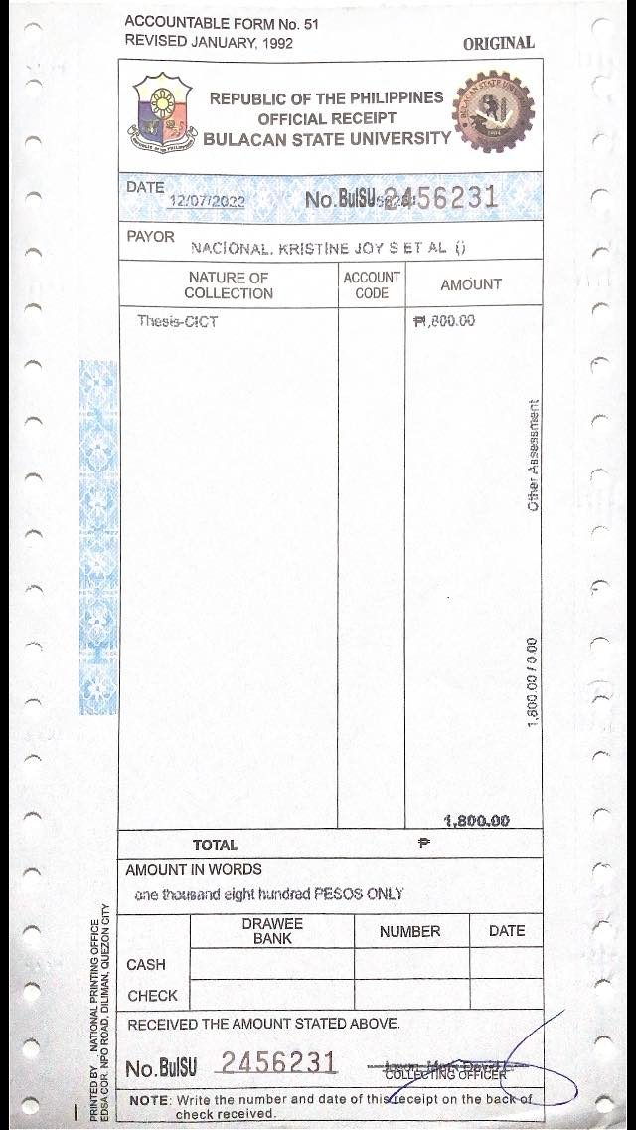Appendix G

Capstone Project Final Defense Evaluation

Appendix H

Certificate Against Intellectual Fraud and Dishonesty

**CERTIFICATION AGAINST INTELLECTUAL FRAUD AND DISHONESTY**

On my honor, I thus certify that the contents of this Capstone Project Documentation are the result of my own intelligence, and that I have properly attributed sources and references. If competent authorities find that what I wrote in this Capstone Project Documentation was gained by fraudulent exploitation of other people's ideas or information, I will bear the penalty or sanction imposed by the College of Information and Communications Technology that goes along with such dishonest behavior.

|  |  |
| --- | --- |
| **Claro, Sharvien Paul M.** |  |
| **Gabutina, Carlo Elijah R.** |  |
| **Mauricio, Angelo D.** |  |
| **Mergal, Jhan Mar D.** |  |
| **Nacional, Kristine Joy S.** |  |
| **Navarro, Rovi Keith Y.** |  |
| **Tapang, Jhel Ansel D**. |  |

*Note: The proponents attached with the certification, the first five pages of the plagiarism report. The complete plagiarism report was submitted to the Capstone Project Coordinator, as part of the requirements of the course.*

Appendix I

User Manual

**CASA REAL SHRINE MUSEUM**

**User’s Manual**

This document was created prior to the use of the VirtualShrine Content Management System. This Document has been issued to the Curator of the Museum as for their reference regarding the use and procedures of reservation of the VirtualShrine Content Management System.

**The Front Office:**

Description: The front office is where the visitors can view the features of the VirtualShrine Website. Navigate the Museum using the navigation features of the system. The Visitor can also make booking anytime of the day.

To access the front office kindly visit http://virtualshrine.online, the home page of the website will appear.

**The Homepage**

The homepage is the main portal to the entire website. It creates the first impression for visitors and quickly comes to represent the museum to its online audience

**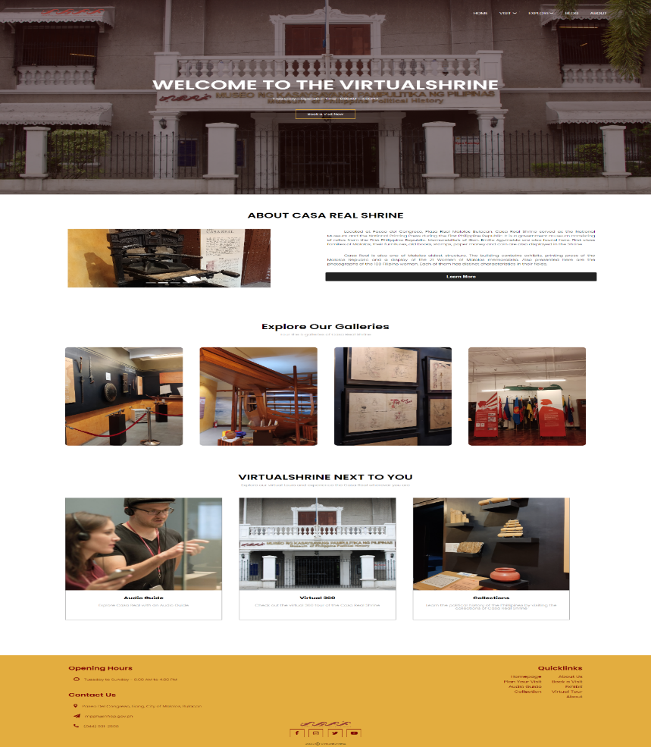**

**The Homepage Header**

The website header is where the navigation tags, book now button, and website logo are located. The navigation tags are located on the top of the header where it is aligned with the logo. The header also provides quick access to the booking form.



**The Homepage Contents**

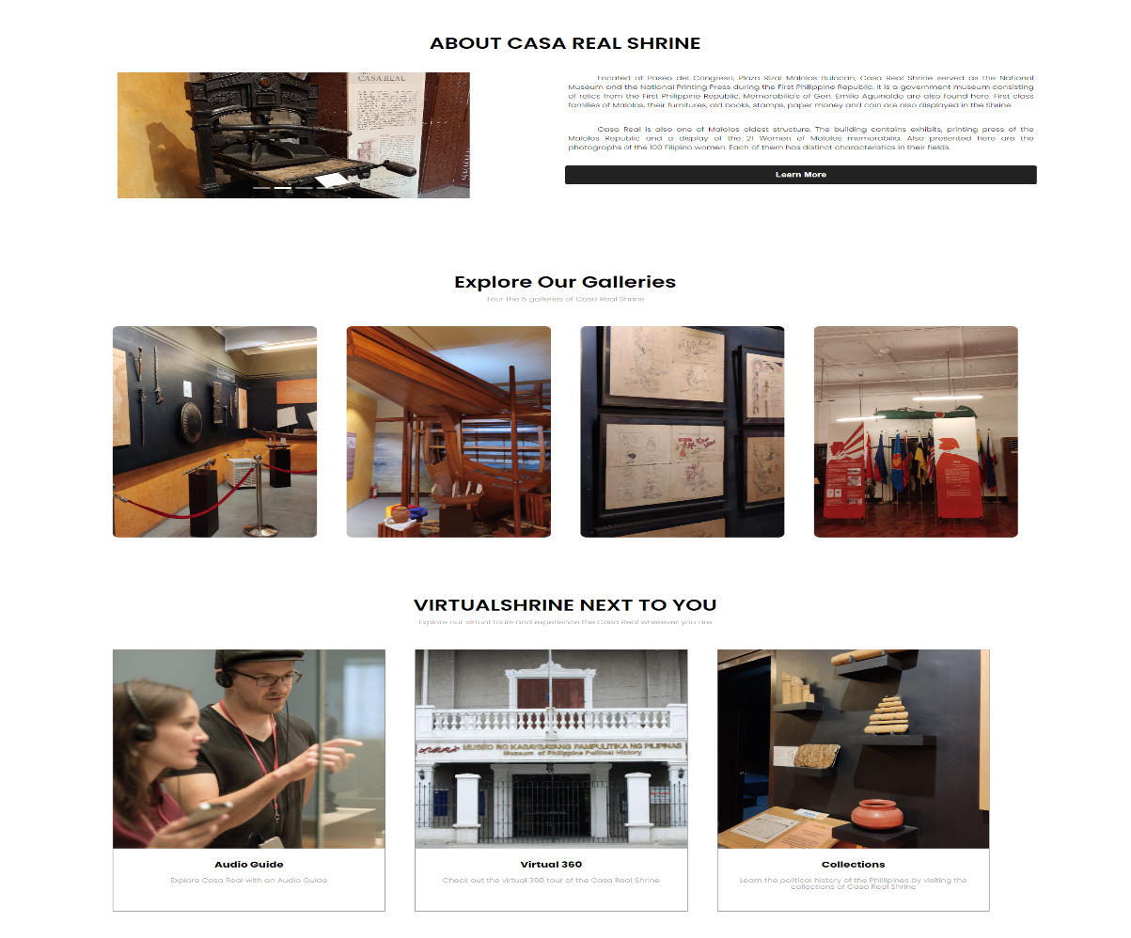 This section displays the highlight features of the website.

**Footer**

This section displays the general information about the museum such as contact information, and social media quick links that can redirect the visitor to the social media accounts of the museum.

**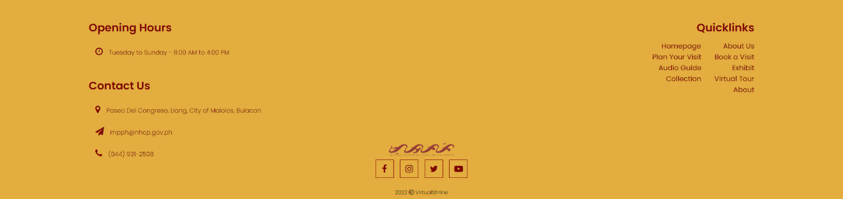**

**Booking Consent Form**

This process allows the visitor to read and understand that the booking process will require the visitor to provide sensitive information. This serves as an agreement between the Visitor and the Museum.

**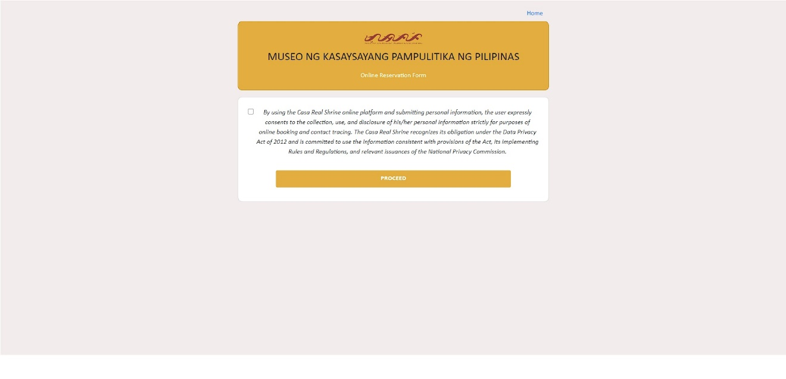**

**The Online Booking Process**

This page is where the reservation process is done. The labels with red asterisk(\*) means that the information is required, and visitor will not be able to proceed without providing the required information.

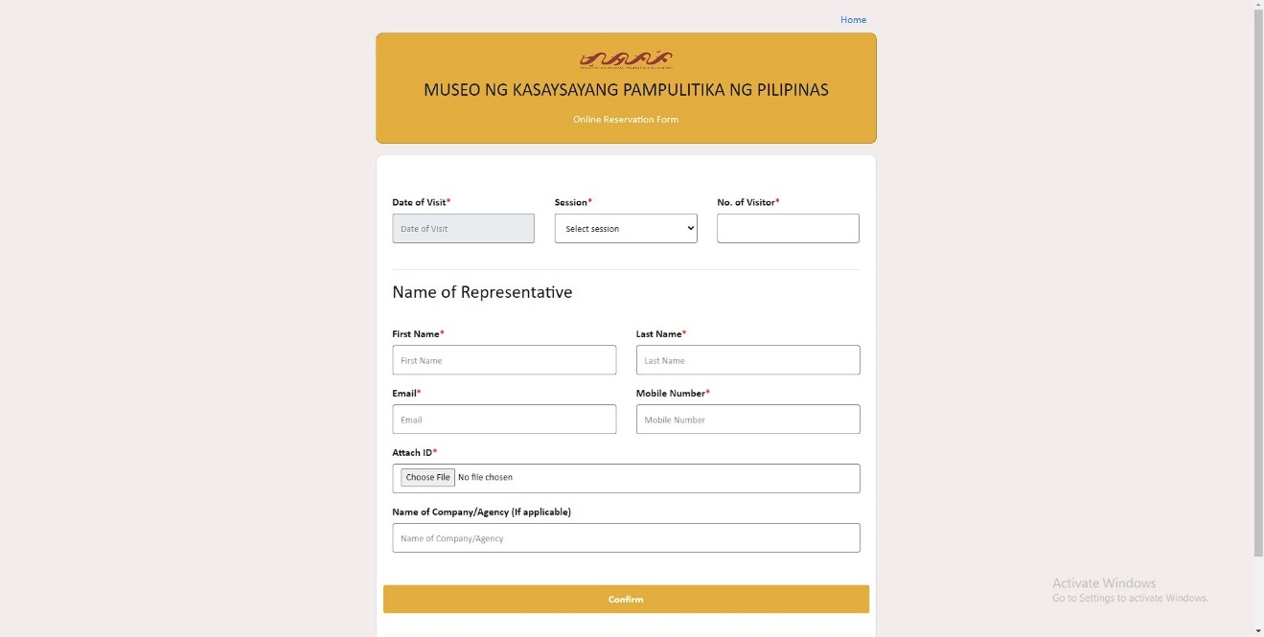

1. **Enter the Schedule of the visit**

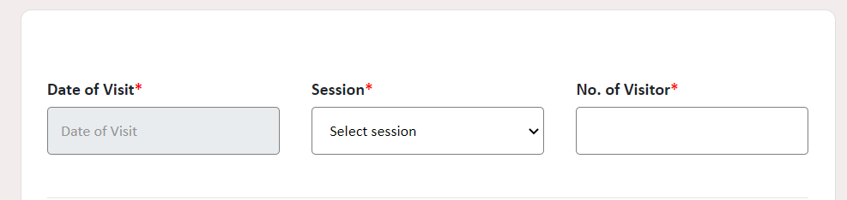This section in the booking form is where the visitor can provide the booking schedule information they want.

**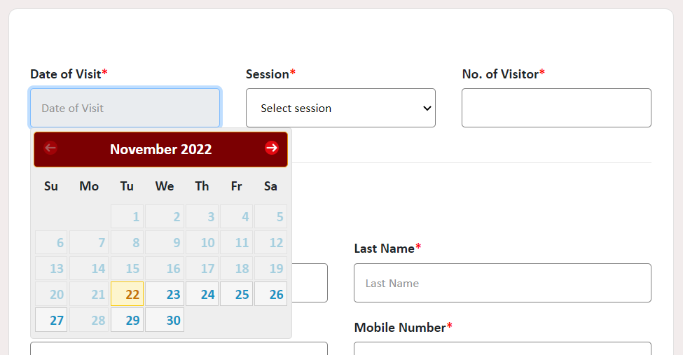**

* 1. **Select a Date**

It allows the visitor to select the date of visit. The calendar also automatically disables the dates that have already passed, as well as the dates every Monday because the museum is closed.

**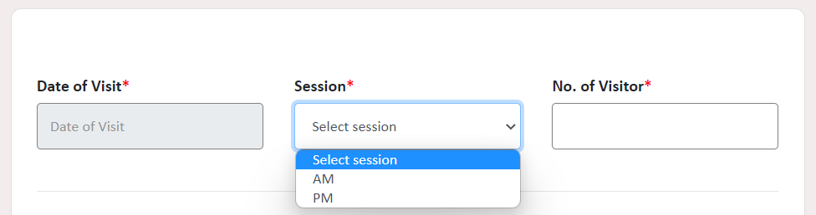**

* 1. **Select Session**

The visitor can select the session of their visit.

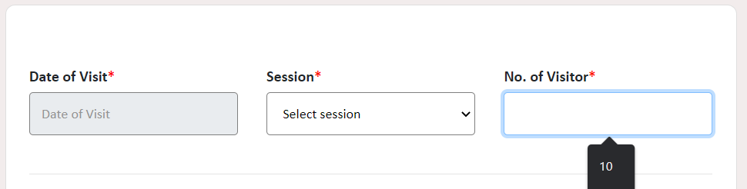

* 1. **Enter Number of Visitor**

This is where the visitor can enter the number of visitors.

1. **Enter Visitor/Representative Information**

This section of the booking form is where the visitor will enter the required information. The following information is needed for communication, and identity verification process.

**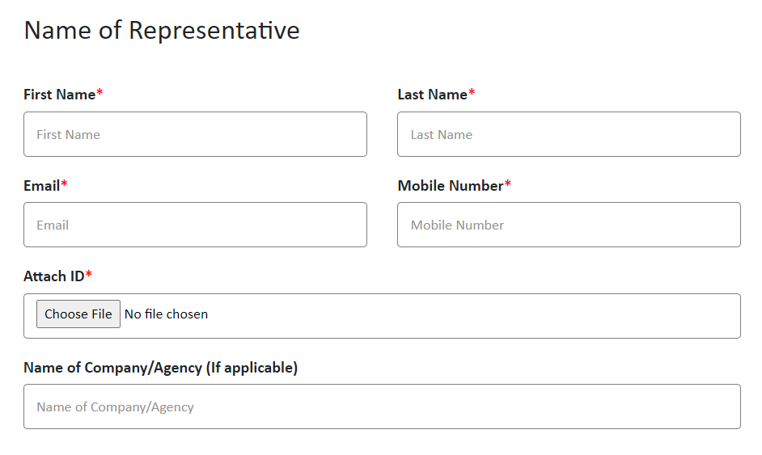**

**2.1 Enter First Name, Last Name, Email, Mobile Number of Visitor**

This is where the user will enter some of the information that the booking form asking like First Name, Last Name, Email and Mobile Number

**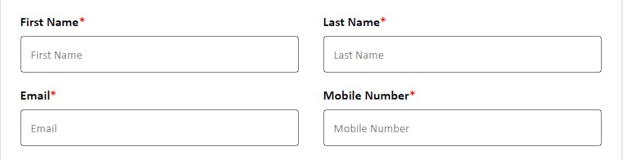**

**2.2 Uploading Valid ID**

The Visitor will upload a picture or their valid ID by clicking Choose File.

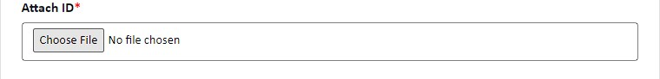

**The Back Office:**

**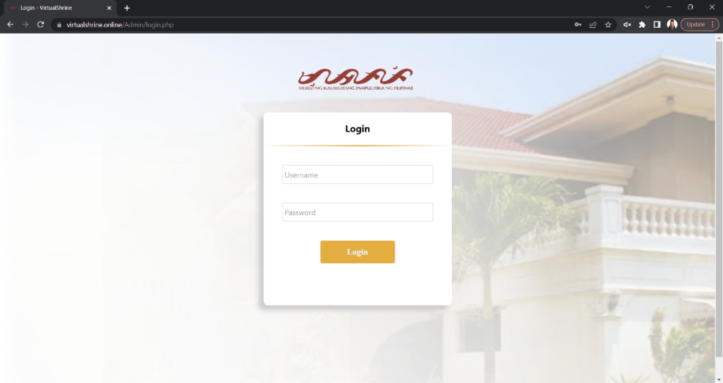**

**The log in page**

The log in page is where the user will use the created account to access the admin page. By entering the correct username and password, if the credentials were incorrect then a prompt will show that they are incorrect.

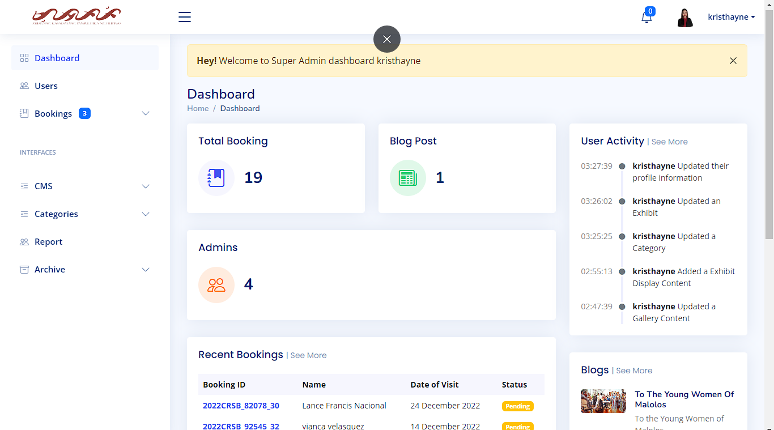

**Dashboard**

After successfully logging in, you will be redirected to the dashboard. Here you will see on the main dashboard are the total booking, blog post, user activity, admins, recent bookings, blogs and user admins. On the left side panel are more tools for the website.

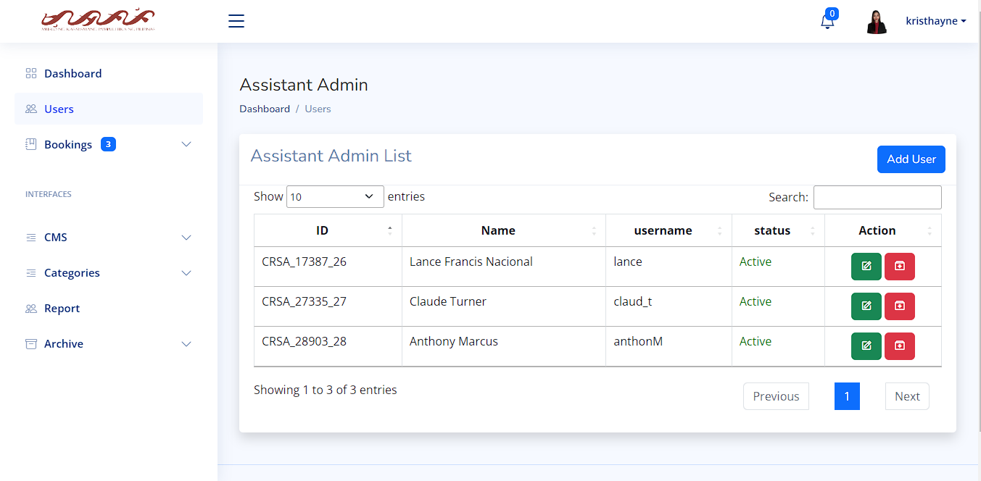

**User/Assistant Admin page**

On this page, the user can add, edit and archive an employee’s account.

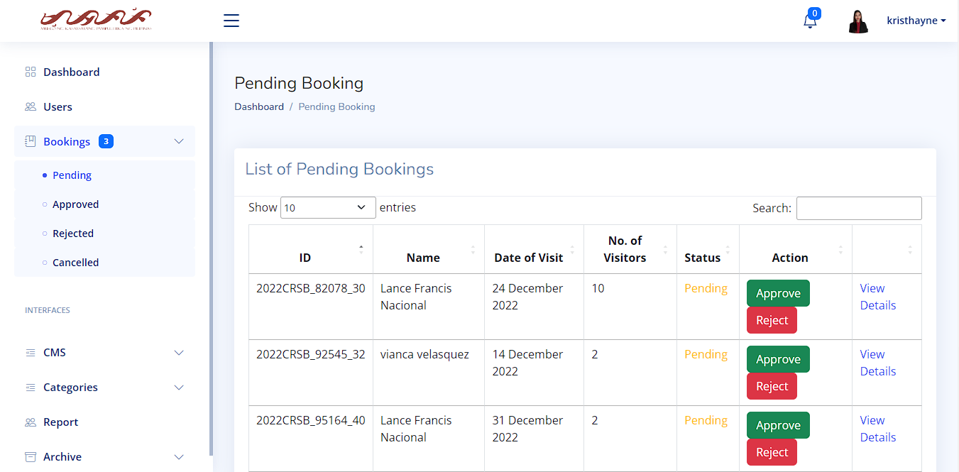

**Booking page:**

1. **Pending Booking**

This page is where the list of pending bookings is kept. List shows the information of each pending requests such as ID, Name Date of Visit, No. of Visitors, Status and Action. The user can approve by clicking the approve button, reject by clicking the reject button and view the details by clicking the view details.

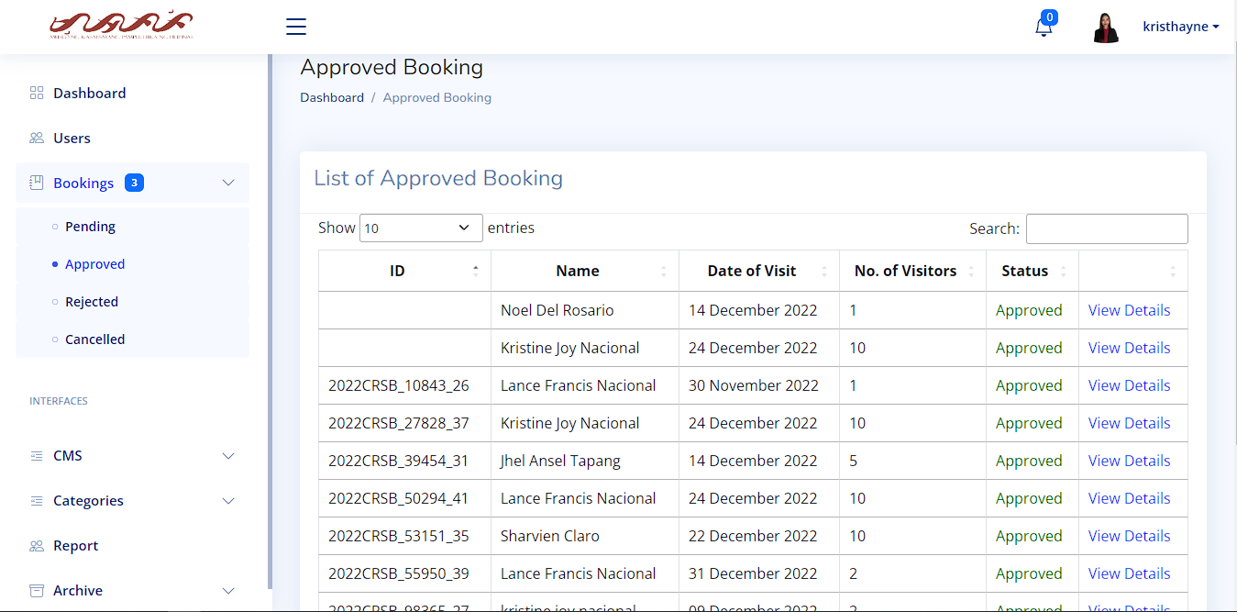

**1.2 Approved Booking**

This page is where the list of the approved bookings is kept. The user can choose to limit the viewed entries by clicking the drop-down icon on the top left and choose whether to view 10 entries up to 100 entries. The user can view the details as well.

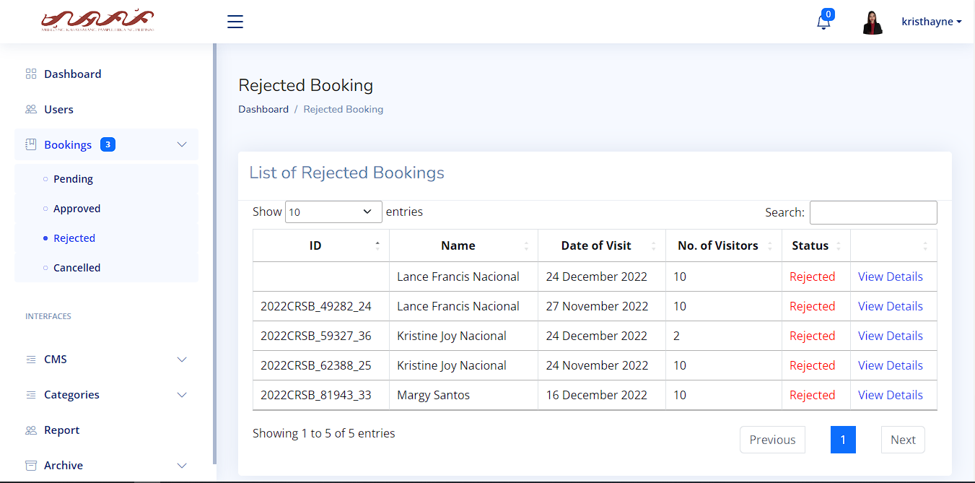

**1.3 Rejected Booking**

This page is where the list of rejected bookings are kept. Same as the Approved Booking, the user can limit the viewed entry list on the top left and view the details.

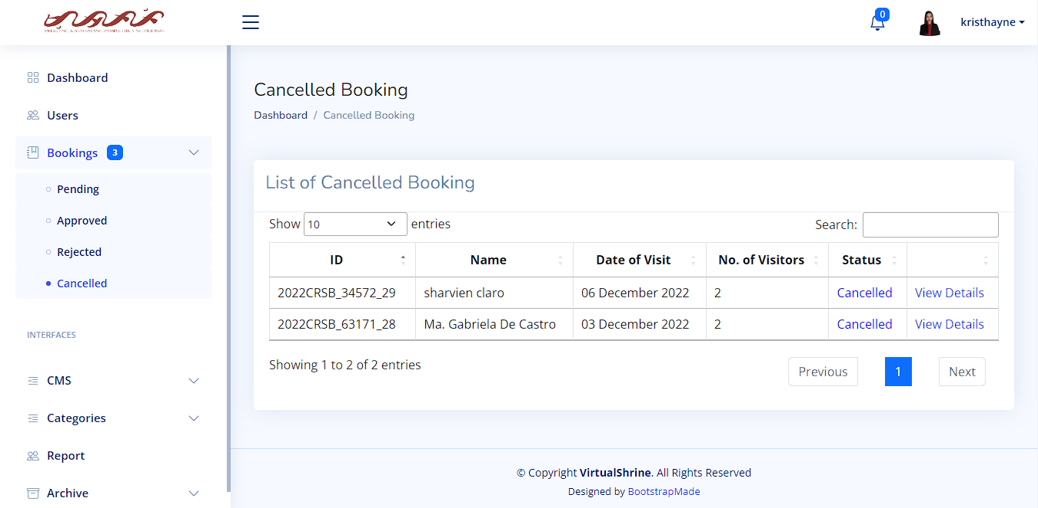

**1.4 Cancelled Booking**

On this page is where the cancelled bookings are kept. Like the Approved and Rejected Booking pages, the user can limit the viewed entry list on the top left and view the details.

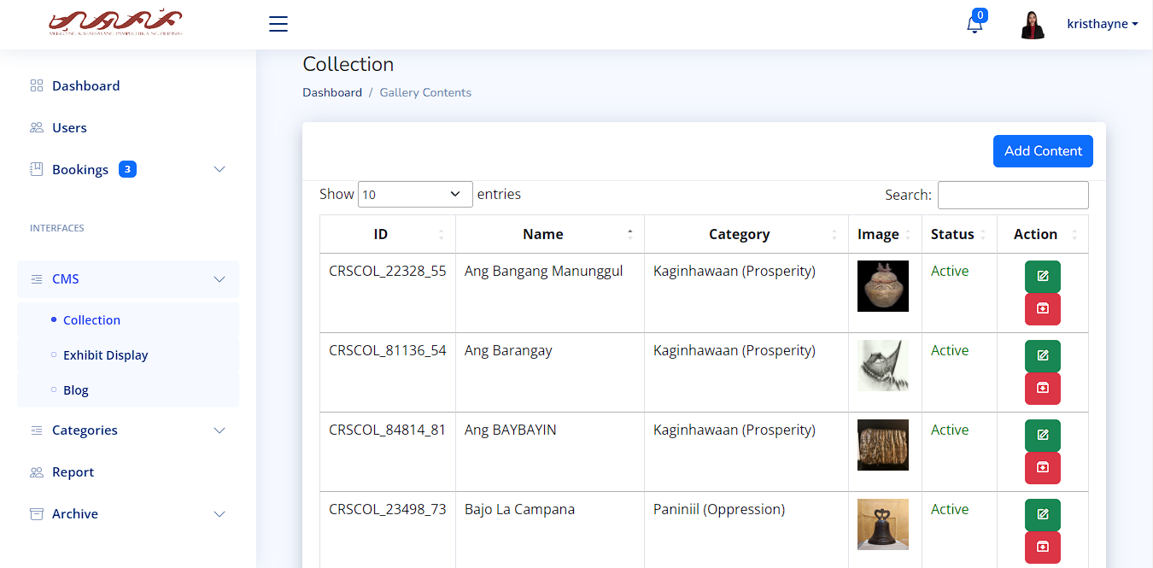

**CMS (Content Management System)**

1. **Collection**

This section of CMS is where the user can see contents of the gallery. Options for

the user to use such as add content by pressing the add content button, on the action tab, the edit button and the archive button, a message will show after successfully archiving a content.

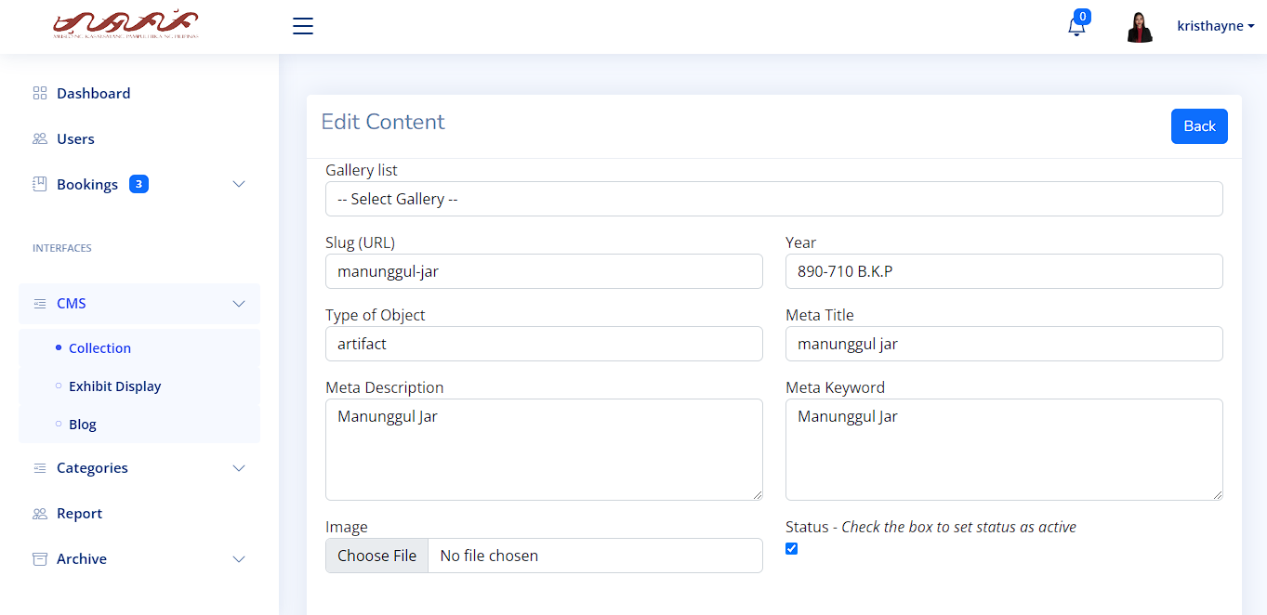

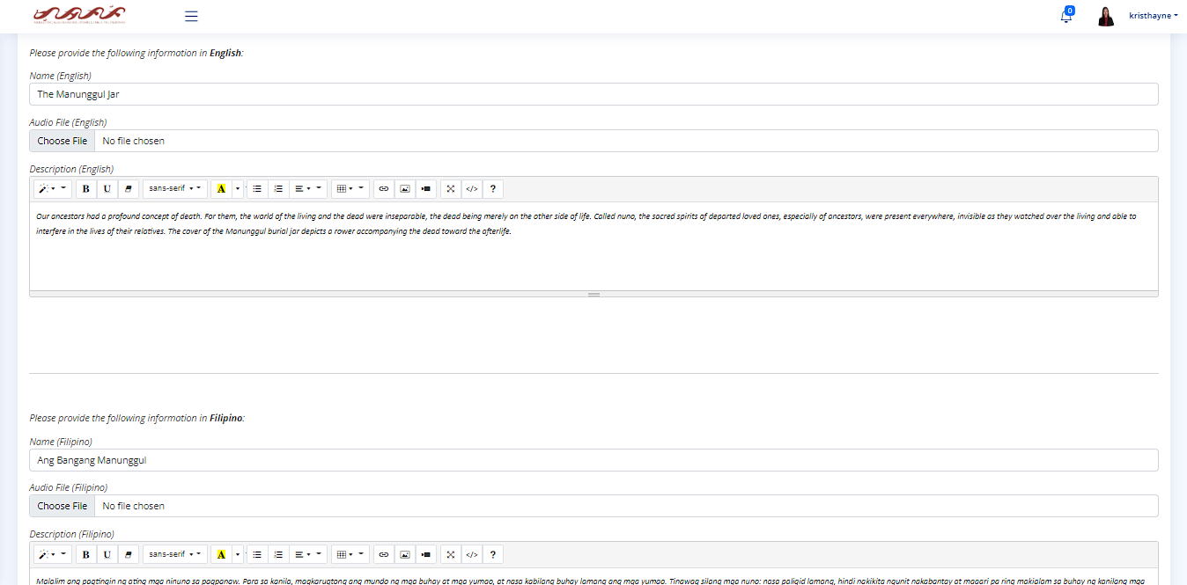

**1.2 Edit Content**

The section of the Collection after pressing the edit button, the user can now add the information on their respected text box. Pressing the status box will make the currently editing content active after pressing the update button on bottom. The user can upload images and audio files for each content made.

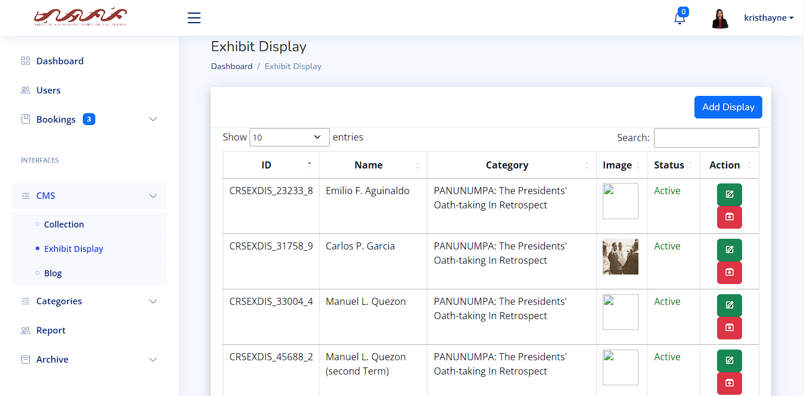

**2.0 Exhibit Display**

This section of CMS is where the user can view the contents of the exhibit displays. The user has multiple options such as adding displays by pressing the add display button, edit by pressing the edit button (the green on the Action tab) and the archive by pressing the archive button (the red on the Action tab).

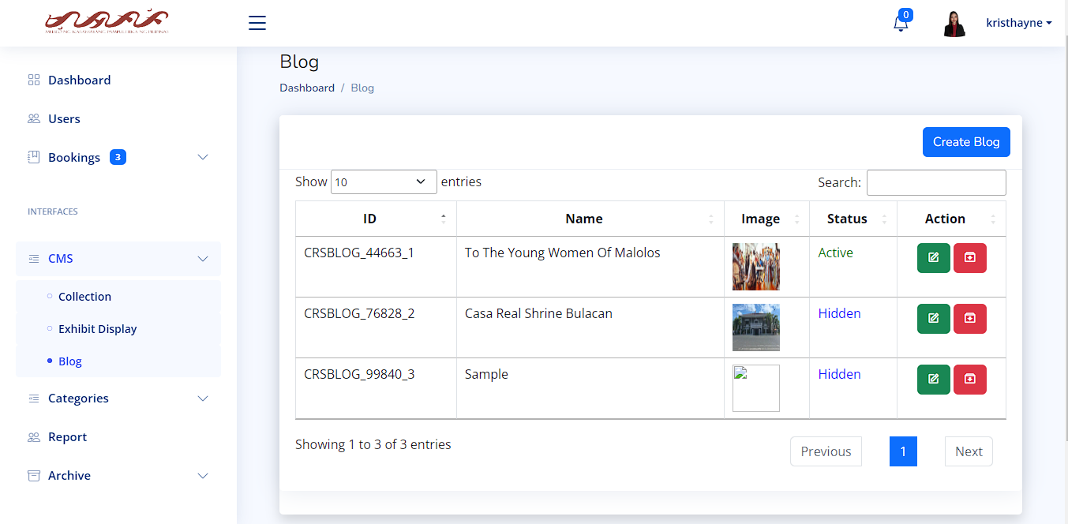

**3.0 Blog**

This section of the CMS is where the user can view the blogs created. With multiple actions the user can do like create blog by pressing the create blog button, editing and archiving blogs by pressing their respective buttons in the action tab.

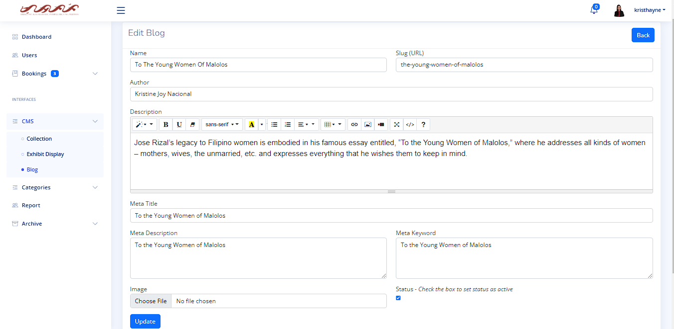

**3.1 Edit Blog**

This section in the edit blog, the user can now put any information necessary on the relevance of the blog the user is planning on creating. The user can also upload images and by clicking the status box, it will make the blog active and show on the website to be seen in public after editing, by pressing the update button.

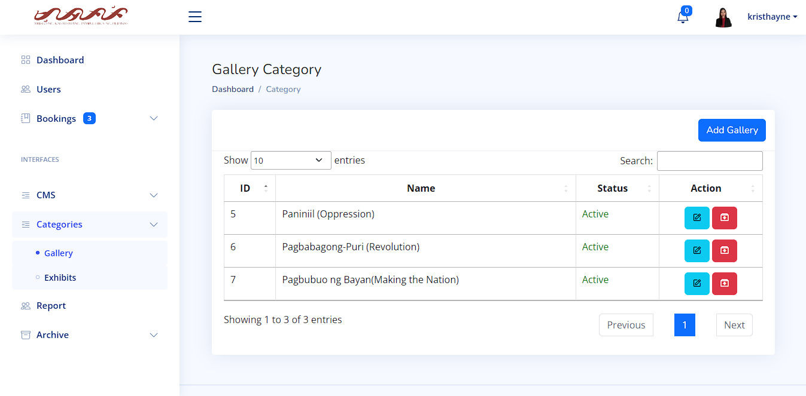

**Categories:**

**1.0 Gallery Category**

This page is where the user can view the gallery category where most of the exhibits are placed and organized in their respective places. The user can add another gallery by pressing the add gallery button, edit and archive a gallery by pressing the buttons on the action tab.

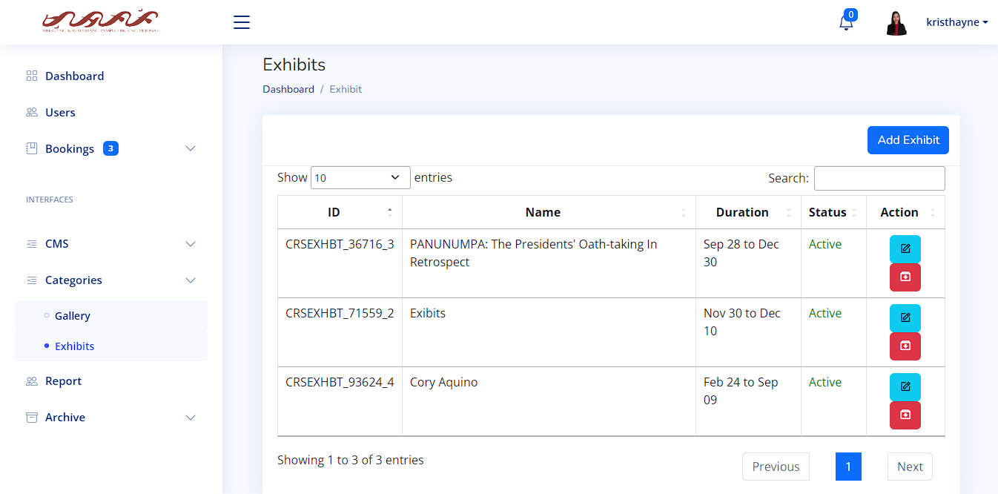

**2.0 Exhibits**

This page is where the user can view the exhibits. The user can add an exhibit by pressing add exhibit button, the user can add the duration of the exhibit to when will it start and when will it end and it will show on the duration tab of the page. The user can also edit and archive exhibits by pressing the buttons on the action tab.

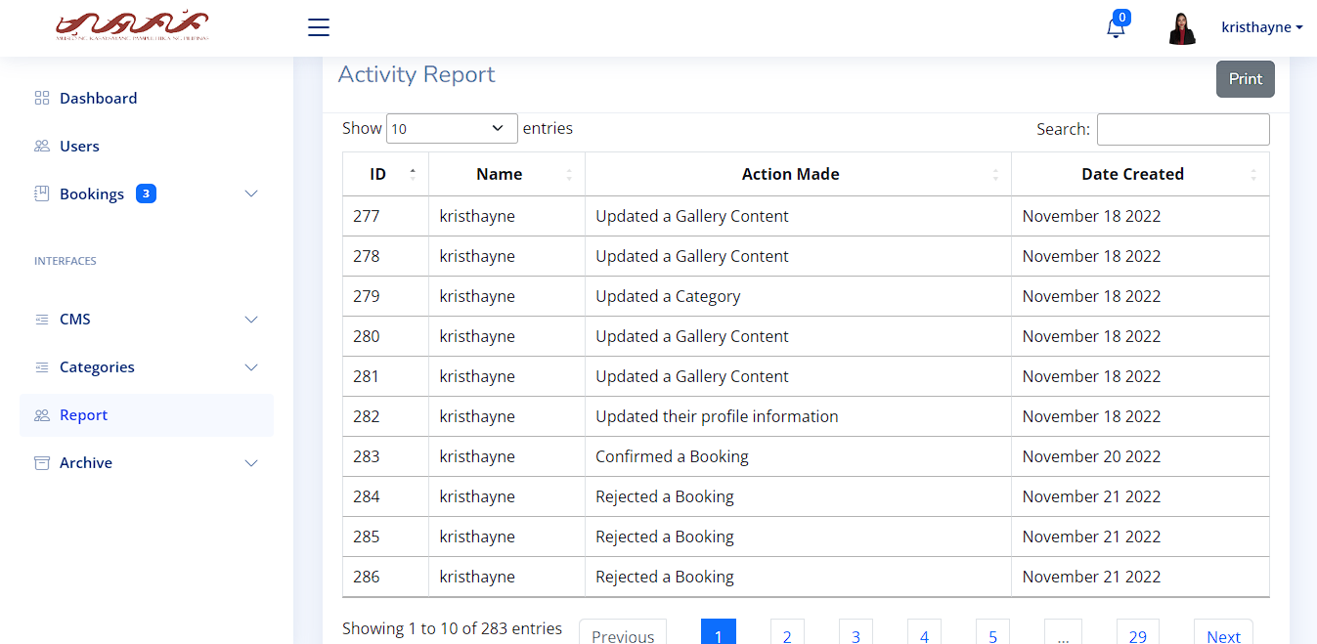

**Activity Report**

The user’s current or previous actions are recorded om this page. They are categorized in ID, Name of the user, Action Made by the user and Date Created. The user can also print the activity report by pressing the Print button.

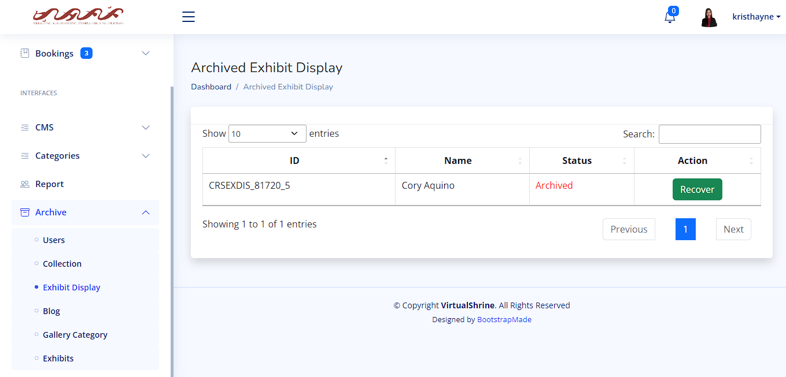

**Archive: User, Collection, Exhibit Display, Blog, Gallery Category and Exhibits**

This page contains all the archived content and are organized based on where the content originally created.

Curriculum Vitae

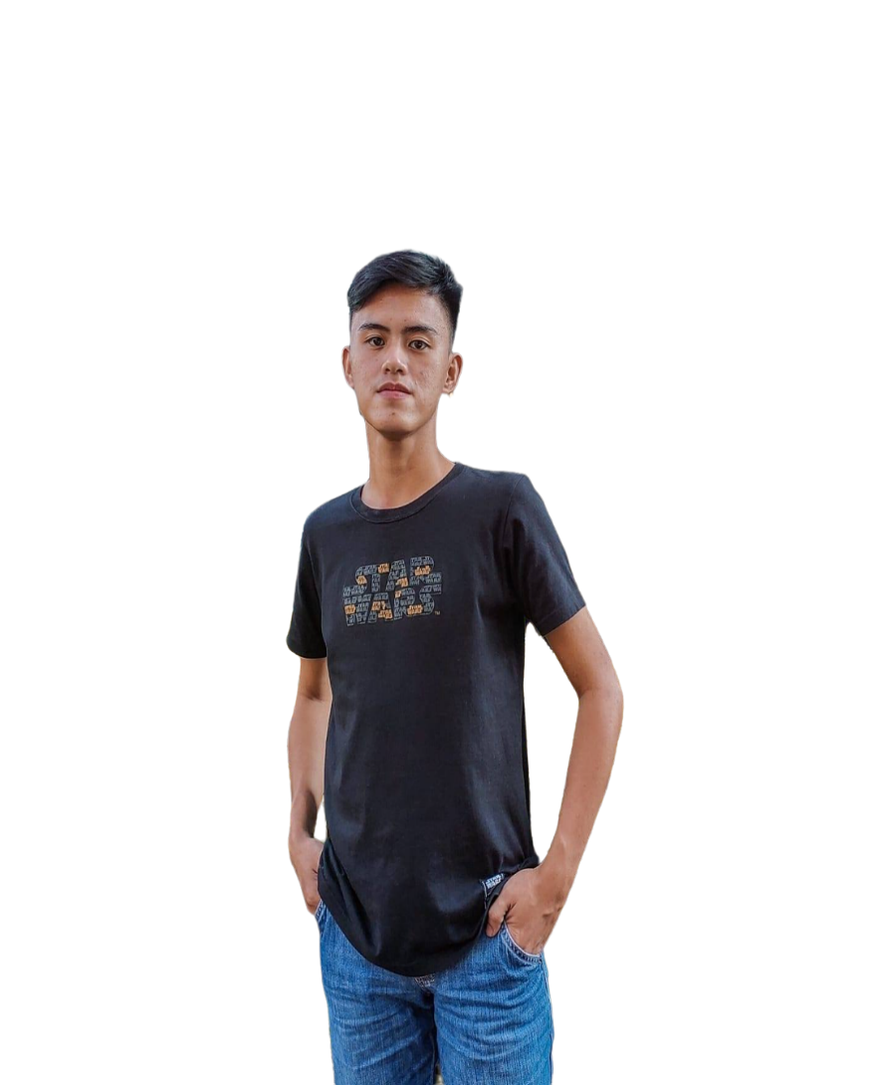

**Sharvien Paul M. Claro**

Borol 2nd Balagtas Bulacan

09062698915

sharvienpaul.claro.m@bulsu.edu.ph

**EDUCATIONAL BACKGROUND:**

**TERTIARY** Bulacan State University (Main Campus)

**EDUCATION:** Malolos, Bulacan

2019 – Present

**HIGHER SECONDARY** Dr. Yanga’s College INC

**EDUCATION:** 182 MacArthur Hwy, Bocaue, 3018 Bulacan 2017 – 2019

**LOWER SECONDARY** Balagtas National Agricultural High School

**EDUCATION:** Pulong Gubat, Balagtas, 3018 Bulacan, Philippines. 2013 – 2017

**PRIMARY:** ABACADA International School

Balagtas, Bulacan

2007 – 2013

**HONORS AND AWARDS:**

HIGHER SECONDARY EDUCATION:

* With Honors

TERTIARY EDUCATION:

* Dean’s List

**TRAININGS/SEMINARS ATTENDED:**

* StackLeague University Series: Bulacan State University Edition (2022)

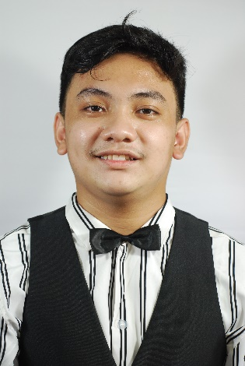

**Carlo Elijah R. Gabutina**

#30 Kilowatt, Meralco Village, Lias Marilao Bulacan

09092065191

carloelijah.gabutina.r@bulsu.edu.ph

**EDUCATIONAL BACKGROUND:**

**TERTIARY** Bulacan State University (Main Campus)

**EDUCATION:** Malolos, Bulacan

2018 – Present

**HIGHER SECONDARY** ACLC College of Meycauayan

**EDUCATION:** MC Mall Building, McArthur Hi-way Banga Meycauayan 2016 – 2018

**LOWER SECONDARY** Barcelona Academy

**EDUCATION:** 35, Lias Road, Marilao, 3019 Bulacan

2012 – 2016

**PRIMARY:** Barcelona Academy

35, Lias Road, Marilao, 3019 Bulacan

2006 – 2012

**TRAININGS/SEMINARS ATTENDED:**

* StackLeague University Series: Bulacan State University Edition (2022)

**WORK EXPERIENCE:**

* Work Immersion
* Assistant to the supervisor in ACLC

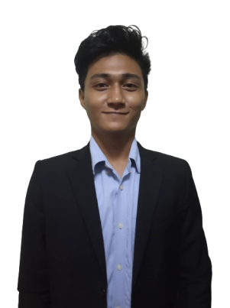

**Angelo D. Mauricio**

164 Agoncillo Street Ana Maria Village Iba Meycauayan Bulacan

09756759366

angelo.mauricio.d@bulsu.edu.ph

**EDUCATIONAL BACKGROUND:**

**TERTIARY** Bulacan State University (Main Campus)

**EDUCATION:** Malolos, Bulacan

2019 – Present

**HIGHER SECONDARY** ACLC College of Meycauayan

**EDUCATION:** MC Mall Building, McArthur Hi-way Banga Meycauayan 2017 – 2019

**LOWER SECONDARY** A.F.G. Bernardino Memorial Trade School

**EDUCATION:** Lias Rd, Lias, Marilao, Bulacan 2013 – 2017

**PRIMARY:** Trinitas College

Pantoc Rd, Meycauayan, Bulacan

2007 – 2013

**HONORS AND AWARDS:**

HIGHER SECONDARY EDUCATION:

* With Honors (Senior High School)

TERTIARY EDUCATION:

* Dean’s List

**TRAININGS/SEMINARS ATTENDED:**

* IT week seminars
* StackLeague University Series: Bulacan State University Edition (2022)

**WORK EXPERIENCE:**

* Work Immersion



**Kristine Joy S. Nacional**

Block 9 Lot 18, Galas Street, Bignay, Valenzuela City

09361685997

kristinejoy.nacional.s@bulsu.edu.ph

**EDUCATIONAL BACKGROUND:**

**TERTIARY** Bulacan State University (Main Campus)

**EDUCATION:** Malolos, Bulacan

2019 – Present

**HIGHER SECONDARY** ACLC College of Meycauayan

**EDUCATION:** MC Mall Building, McArthur Hi-way Banga Meycauayan 2017 – 2019

**LOWER SECONDARY** Antique National School

**EDUCATION:** Tobias A. Fornier Street, San Jose de Buenavista, Antique 2013 – 2017

**PRIMARY:** Malandog Elementary School

Malandog Hamtic Antique

2007 – 2013

**HONORS AND AWARDS:**

PRIMARY:

* Class Valedictorian (Class 2012 – 2013)

HIGHER SECONDARY EDUCATION:

* With Honors (Grade 11)
* With High Honors (Grade 12)

TERTIARY EDUCATION:

* Dean’s List

**TRAININGS/SEMINARS ATTENDED:**

* StackLeague University Series: Bulacan State University Edition (2022)

**WORK EXPERIENCE:**

* Special Program of the Employment of Students (SPES) - 2015
* Work Immersion

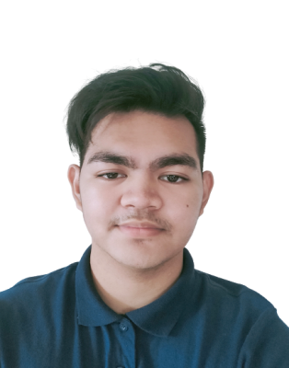

**Rovi Keith Y. Navarro**

165 Purok Rosal Caduang Tete Macabebe Pampanga

09612947453

rovikeithn@gmail.com

**EDUCATIONAL BACKGROUND:**

**TERTIARY** Bulacan State University (Main Campus)

**EDUCATION:** Malolos, Bulacan

2019 – Present

**HIGHER SECONDARY** Pampanga Colleges

**EDUCATION:** Poblacion Macabebe Pampanga 2017 – 2019

**LOWER SECONDARY** Caduang Tete High School

**EDUCATION:** Purok Rosal Caduang Tete Macabebe Pampanga 2013 – 2017

**PRIMARY:** Caduang Tete Elementary School

Centro Caduang Tete Macabebe Pampanga

2007 – 2013

**HONORS AND AWARDS:**

HIGHER SECONDARY EDUCATION:

* With Honors (Senior High School)

**TRAININGS/SEMINARS ATTENDED:**

* IT week seminars
* StackLeague University Series: Bulacan State University Edition (2022)
* Research seminar in Pampanga Colleges

**WORK EXPERIENCE:**

* Work Immersion
* Assistance to the Administrator in STI

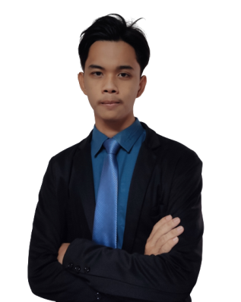

**Jhel Ansel D. Tapang**

05-B Purok 1 Lugam Malolos Bulacan

09125216212

jhelansel.tapang.d@bulsu.edu.ph

**EDUCATIONAL BACKGROUND:**

**TERTIARY** Bulacan State University (Main Campus)

**EDUCATION:** Malolos, Bulacan

2019 – Present

**HIGHER SECONDARY** La Consolacion University Philippines

**EDUCATION:** Bulihan Malolos Bulacan

2017 – 2019

**LOWER SECONDARY** Dampol 1st National High School

**EDUCATION:** Dampol Plaridel Bulacan

2013 – 2017

**PRIMARY:** Santisima Trinidad Elementary School

Santisima Malolos Bulacan

2007 – 2013

**HONORS AND AWARDS:**

HIGHER SECONDARY EDUCATION:

* With Honors (Junior High School)

**TRAININGS/SEMINARS ATTENDED:**

* CICT Week
* IT Week Seminar
* StackLeague University Series: Bulacan State University Edition (2022)

**WORK EXPERIENCE:**

* Work Immersion